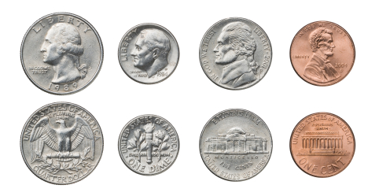

How Much Money Is In Your Piggy Bank?